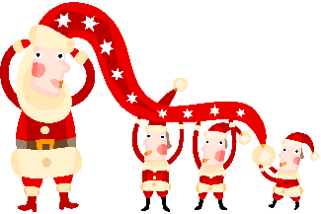
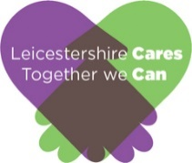
COLLECTION POINT
Collect 4 Christmas
Supporting those affected by homelessness

Adults Toiletries Pack
- Towels
- Toothbrush & toothpaste
- Soap
- Shower gel and shampoo
- Comb or brush
- Deodorant
- Sanitary wear products
Unisex Bedroom Pack
- Single duvet
- Single duvet cover set
- Single fitted sheet
- 1 pillow

Kitchen Pack
- 4 mugs
- 4 glasses
- Cutlery set (16 set)
- Crockery (16 piece)
- Toaster
- Kettle
- Assorted utensils
- Tea towels
- Multi-purpose cleaner
- Cloths/cleaning sponges
- Frying Pan
- Sink Drainer
- Dust pan and brush

Help The Homeless – Starter Pack Items

Gifts 4 Kids – Collection of toys and gifts from £5 to £20 for 0-18 year olds

Baby Toys | Cuddly Toys | Craft Activities
Puzzles | Board Games | Watch/Jewellery Items
Pyjama Sets | Sports Games | Tech Toys

