 **Employability Projects Impact Report 2017-18**

This year has been a busy one for our employability projects. Running in **19** of our partner schools, we have involved **57** volunteers from **31** companies and have engaged **3169** students. The projects on offer have given us the opportunity to establish a good range of employability activities to support students and to help schools achieve their careers benchmarks. They have also proved popular with our businesses, many of whom are keen on this type of activity as it meets their skills and business needs while providing a wider offer for staff. Speedy Speakers has allowed us to engage senior professionals who might otherwise not have the time to engage with Education. I would like to thank all those involved in this area of Education work throughout the year and look forward to seeing the impact of these as they begin to roll out on a larger scale.

**Gail Brown, Education Manager, Leicestershire Cares**

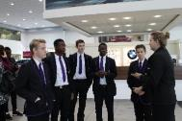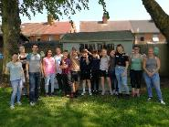

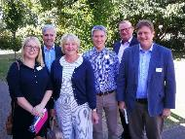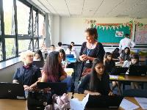

*"I have benefited by learning more about how different jobs work together towards one job’*

**Student, New College Leicester**

*“I thought it was a great session and well planned – from my perspective it was good to know more about the students in advance of talking to them and also have the laptop available to do some live research during the discussion.”*

**Volunteer, Thermofisher**

*'I was delighted to meet the A Level law students and to share my career story and experiences with those who are at the beginning of what will undoubtedly be many long and successful law careers’*

**Volunteer, Cummins Solicitors**

Some examples of some of our Employability activities:

* Small group, curriculum and assembly speakers events, most popular being our Speedy Speakers programme culminating in a Speedy Speakers Festival at Rushey Mead School.
* Skills workshops which developed into a CV workshop for classes and culminating in a whole year group workshop at Soar Valley College.
* Following a CV workshop, Team Challenges were piloted with business volunteers working alongside students from Hinckley Academy at Hinckley East Sure Start.
* Apprenticeship recruitment interviews and skype interviews as part of our Interview Technique Project.
* Support to schools with their careers events, apprenticeship fairs and work tasters.

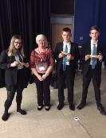

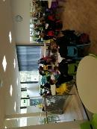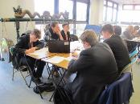

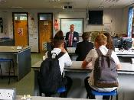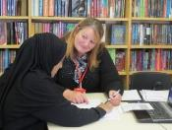

*Speedy speakers were inspirational and motivating*

**Student, Rushey Mead Academy**

*His message was pitched perfectly for the age group, the students were engaged and listening and it was so good to have a future employer come in to speak about expectations in the work place.  I particularly liked the use of ‘POLITE’ and linking it to skills that the students need to put into place now.  It will be something I will be using it in future!*

**New College Leicester**

*This was a great opportunity to hear from some incredibly talented and authentic leaders.  I only hope that the students got as much out of hearing about their experiences as I did!*

**Volunteer, Cambridge & Counties Bank**