

SBSC making a difference in our community …

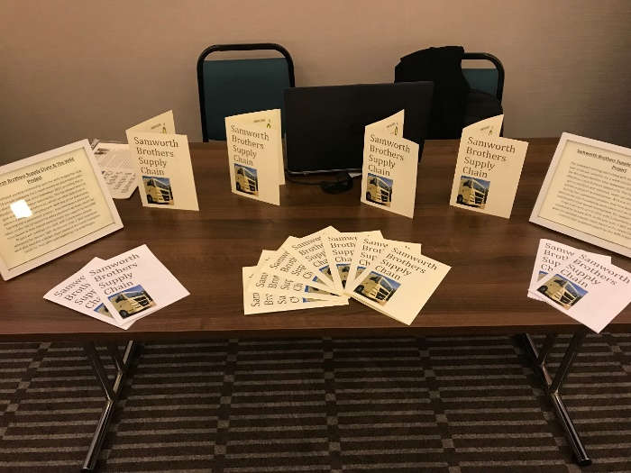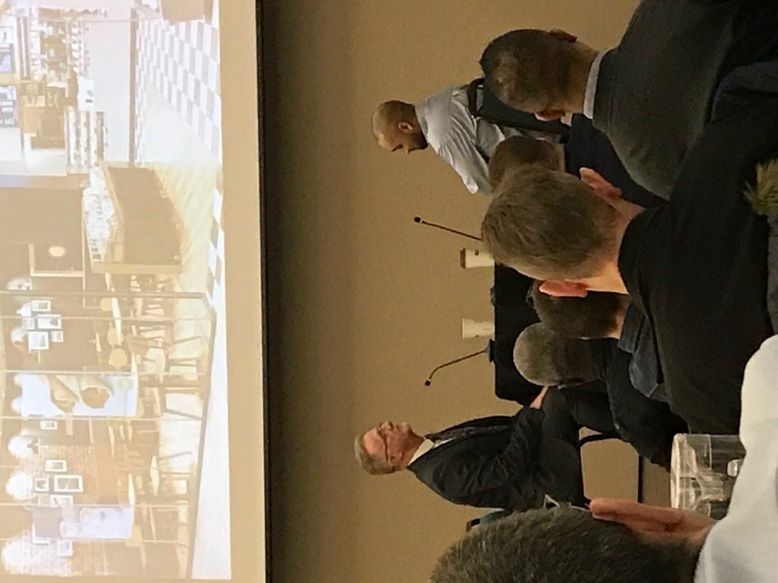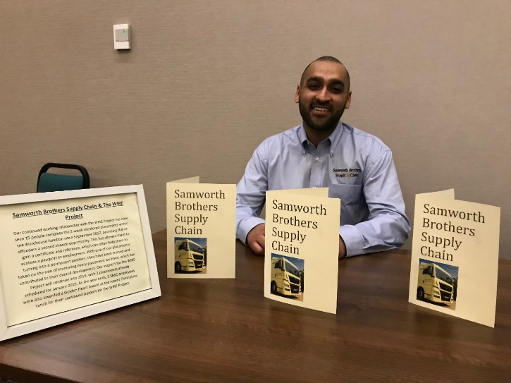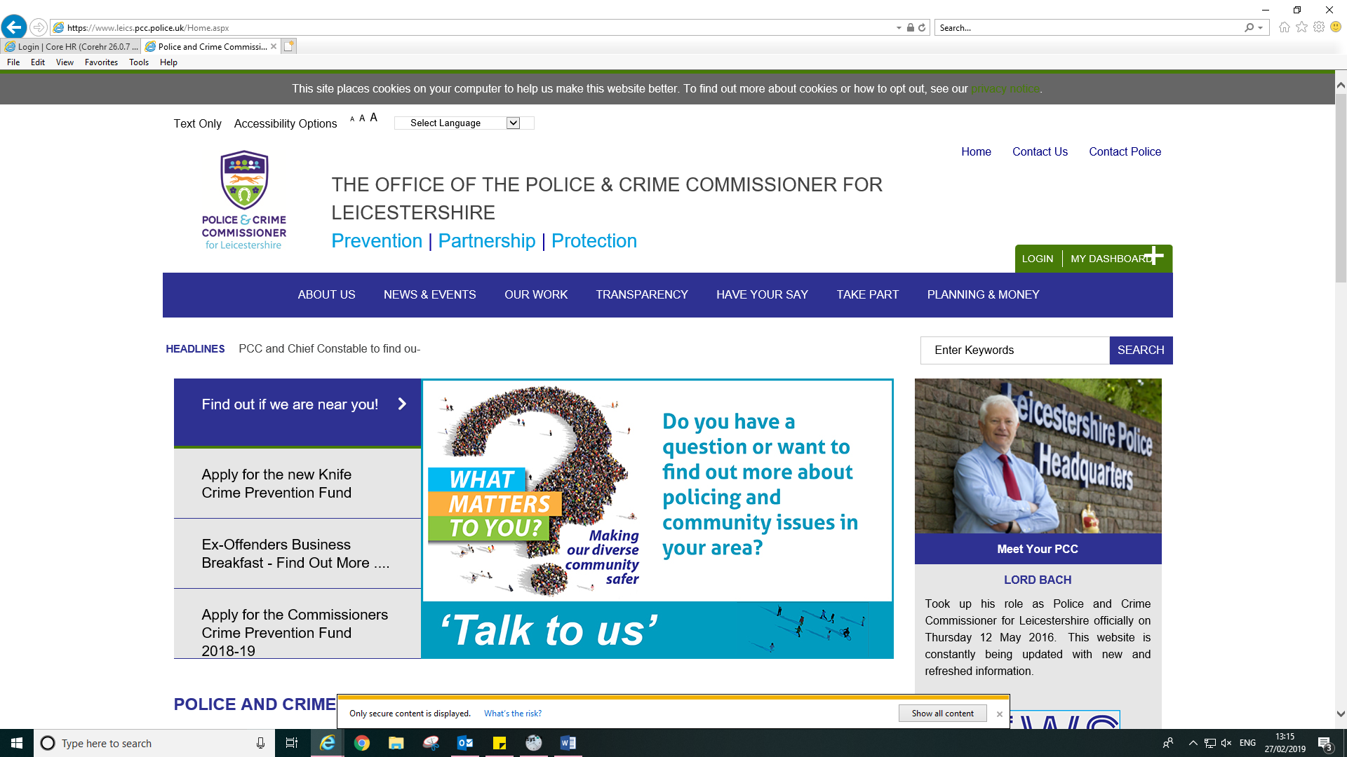**Imran Litt (Warehouse Operative)** was invited to attend the PCC Business Breakfast Event held at Attenborough Hall in Leicester with Lord Willy Bach, Police and Crime Commissioner (pictured left). The event was to enable companies to explore further opportunities in employing ex-offenders and for those already employing ex-offenders to share their experiences. Imran was one of the selected to share his testimony where he expressed how grateful he was to Samworth Brothers Supply Chain for the opportunity and second chance. Imran joined SBSC through a 2-week voluntary placement, followed by agency and soon after was offered a permanent position. Imran would personally like to thank Dennis Sayer (WIRE Project Manager), his Managers Kurt Henney & Ian Hemsley as well as Cassie Hill (Personnel Manager) and Nellie Mantina (Personnel Officer) for the support. Imran hopes to further his career at SBSC and looks forward to the future.

SBSC table, where we spoke to WIRE Project clients and other companies who are interested in the WIRE Project.

Imran with Dennis Sayer (WIRE Project Manager) in an interview style conversation sharing his experience

