Interview Technique Impact Report 2017-18

25 events were held at 24 of our partner schools this year with 300 volunteers from 58 businesses involved. Together they helped us to support a phenomenal 4859 students with an in depth one-to-one mock interview and feedback to support them with the next stages of their career. Interview Technique has supported 49,397 young people over the last 14 years, with new schools signing up ready for next year.

Whether you have supported this project as a volunteer, helped recruit volunteers from your business or set up the project in your school, each valuable role has helped provide students with the employer encounters with employers they desperately need to raise aspirations and make informed choices.

I would like to take this opportunity to thank everyone involved in making this project a success across the course of this year and look forward to working with you all again in 2018-19.
Gail Brown, Education Manager

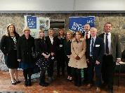
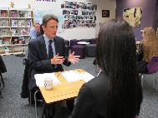
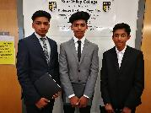
She opened my mind to the world and helped me think about what I personally want to do in the future
Student, New College
All of our students found the Interview Technique activity extremely beneficial and will now use the skills they are developing in their upcoming College interviews
City of Leicester College
I would like to thank you all for your empathy, professionalism and patience. This will give our students a realistic experience of what is expected during their next phase of education.
Keyham Lodge School

- 100% of schools rated the Interview Technique programme as excellent (89%) or good.
- 100% of schools rated Leicestershire Cares’ management / organisation as excellent (83%) or good.
- 100% of schools rated the improvement of their students as excellent (89%) or good.
- 94% would recommend it to other schools.
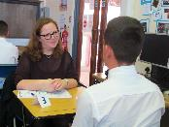
We asked the students what they thought about their experience…
- 90% said they enjoyed the activity.
- 96% found the activity useful.
- 86% felt the interview went well.
- 88% said that they felt more confident about attending interview.
- 97% felt their interviewer gave them good advice.
- Only 6% said they felt their mock interview had changed what they would do in the future.
- 76% will take action to ensure they are able to perform better at your next interview.

Volunteers:
- 96% would recommend the project to another person.
- 92% rated the project as excellent or good.
- 92% volunteers felt they had gained skills from their involvement with Interview Technique, most commonly felt they had gained were coaching and mentoring skills (94%), feedback and evaluation skills (89%), listening skills (78%) and motivating others (72%).
This is our fourth year of delivering Interview Technique and it never fails to deliver. The students always get a great experience that builds their confidence and makes them much more "work ready". It is always the students I'm concerned about that get so much from the day.
Limehurst Academy
The interviewers won't judge you if you slip up or stumble; they're there to give you feedback and advice. The anticipation is worse than the actual thing.
Student, Lutterworth High
Honestly, its a great experience and a really good chance to show off your ability without the real pressure of an interview. Use this experience as you will benefit highly.
Student, Beaumont Leys

