Go for Reading Impact Report 2017-18

The Go for Reading project provides one-to-one weekly support to targeted 11-13-year olds who are struggling with their reading. By working with the same students each week, 45 volunteers helped their 81 young partners in 9 schools to progress in their ability, understanding and enjoyment of reading while building confidence and communication skills.
This year we have engaged new companies and trained committed volunteers who will shortly become excellent Go For Reading mentors. These companies include Evolve, Caterpillar and Semelab.
I would like to take this opportunity to thank all the superb volunteers and companies that have supported Go for Reading so brilliantly this year including Alltruck, Checkprint, Cloudcall, Europcar, Office Depot, Walkers and Son, Leicester City Council, HRBS, Howes Percival, Ford and Slater, Fisher Scientific, NMBS and Spearing Waite. I look forward to working with you all this year.
Helen Treadwell - Development Officer, Education.

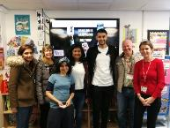

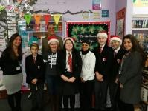
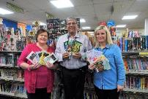
The students look forward to reading every week and are sad if it is cancelled for any reason. They feel special that the volunteers are giving up their time to help them.’
Babington Academy

Go For reading has made me feel happier as I have learnt lots of new words.
Student Moat CC.
There is a noticeable improvement in fluency and vocab recognition amongst students. Lots of them have signed up to Reading Rampage to challenge themselves.
Babington Academy

Criteria for selection: Students all lack confidence, ability and are reading below their age expected levels.

- 98% schools felt that Go for Reading had supported their students’ progress.
- 96% pupils increased their self-esteem & self-confidence.
- The students increased their reading age by an average of 20 months, with 55% increasing their reading age by more than 1 year and 70% by more than 6months.
- 66% of the students were from City Schools and 33% from County Schools.
- 58% of the students were boys and 42% girls.
“It was great to meet up with one of my previous students with whom I had built up a terrific rapport. She made a massive impact on me during the year we read together. and always put a smile on my face. It was an absolute pleasure reading with her.
Volunteer, Fullhurst Community College
- 83% had Special Educational Needs.
- 42% of the students were White British.
- 46% spoke English as an additional language (EAL)
- 98% of the students felt that their Go for Reading partner had helped them.
- 98% students enjoyed Go for Reading.
- The number of students who felt they were good at reading increased from 28% at the beginning to 78% at the end.
Volunteers:
- 100% rated the project as excellent or good and 100% would recommend it to another person.
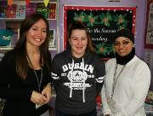
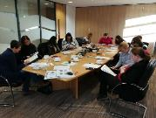
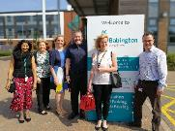
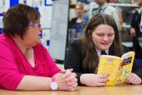
- 100% felt they had gained skills from Go for Reading, most commonly listening skills (85%), coaching and mentoring skills (77%), motivating others (92%) and communication skills (62%).

