#PowerToChange Community Partners network partnership agreement

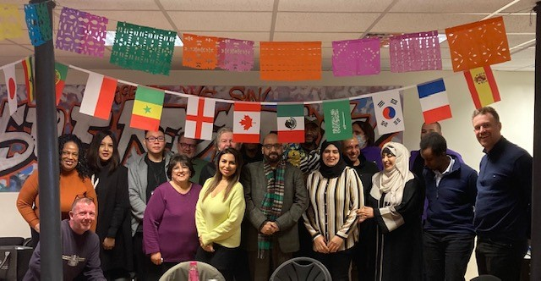
Introduction.
The #PowerTo Change partners group has been meeting regularly since May 2022. In that time, it has become a safe and trusted space for community partners to meet and share issues, concerns and learning . It has also provided a platform for the group, to feed into local and national policy work and has built positive working relationships, with the City Council, NHS, OPCC/VRN as well as think tanks such as the CSJ and Compass.
Purpose: To provide an opportunity for a diverse range of frontline community groups from across Leicester City , to share and reflect on their practice and to use learning arising to influence and shape relevant local and national policy and decision making and improve service provision.
Goal: A Leicester city where everyone has access to the support, services and opportunities that enable them to thrive and live happy, healthy, safe, secure, rewarding and fulfilling lives:
Key values and methodologies.
Partnership: We believe that partnership both within the community sector and between, community, public and business sector is key to delivering our goal.
Creativity and agility: We live in a fast paced ever changing complex world , so for organisations to be effective they need to be creative and agile and willing to adapt so they can respond to the ever changing demands and issues.
Working without “ego, silo or logo”, is key if we are to learn from each other and to develop effective practice and solutions.
Lived experience and voice of the young people, families and communities we work with should drive and lead the work, they are an asset and the solution not the problem.
Diversity and inclusion. We will proactively seek to ensure we identify and remove barriers that prevent people from participating in our group or thriving within, our city.
Reflection and learning. We are committed to learning from our practice, both its successes and failures, so we can continually adapt and improve.
Membership.
Membership is free and open to all community groups within Leicester city who share our goal, methodologies and values.
How group will operate.
Leicestershire Cares will coordinate the group and provide administration, secretarial and policy support, along with meeting rooms.
The group will meet every 6/8 weeks and it is envisaged that each meeting will:
- Give participants an opportunity to share and learn from each other.
- Provide an opportunity for participants to meet with key local, regional and national decision makers and politicians who we wish to learn from, partner with and influence
- As group develop it is envisaged that key policy “asks” will be identified and sub groups from the group will lead on agreed actions.
- We will aim to have an annual celebration of the community sector where we highlight achievements, challenges, emerging issues and key policy asks.
- We will also seek to use creative arts and media, alongside social media to promote the work of the group.
Issues we wish to tackle.
We are very aware that the people we work with face a complex range of interlocking and ever changing issues. As we are committed to being creative and agile, we will adapt as issues change and arise but based on our work since May 2022, we envisage issues we will want to work on and tackle will include:
Poverty and welfare provision. Leicester is a poor city with 40% of children living in poverty and this has been exacerbated by the ongoing impact of the prolonged lockdown in our city, and the cost of living crisis.
Race, immigration, asylum system and language. Many of the poorest people in our city our immigrants, asylum seekers or refugees. They are often “exploited” in both the workplace and housing sector, unaware of their rights and hugely affected by government policy that denies them the right to work or access to benefits. In addition, many struggle with communicating in English, which makes it even harder for them to understand and access their rights and entitlements.
Youth provision. Youth services and provision have been badly hit by ongoing cuts.
If we want young people to thrive and not be vulnerable to “bad influences” then youth services have a huge role to play in providing support, opportunities, positive pathways and connection between communities.
Proactive systemic partnership work. Sadly, it is often the case, for a range of reasons that the public sector does not involve the community or business sector in proactive systemic partnership work. As a result, our input is often via last minute consultation or ad hoc opportunities to comment.
Health and mental wellbeing. Leicester remains a city where different postcodes have different life expectancies and access to health and mental health provision is patchy and often based on assumption you can speak English.
Highlighting needs of specific groups. Through our work we are aware of specific groups, such as care experienced young people, prisoners’ children or families where little or no English is spoken, whose needs are often overlooked, misunderstood or ignored.
Digital exclusion. Increasingly many services and access to support are offered digitally and there are significant numbers of people in the city who are excluded by this approach , due to lack of equipment, digital connection and digital skills.
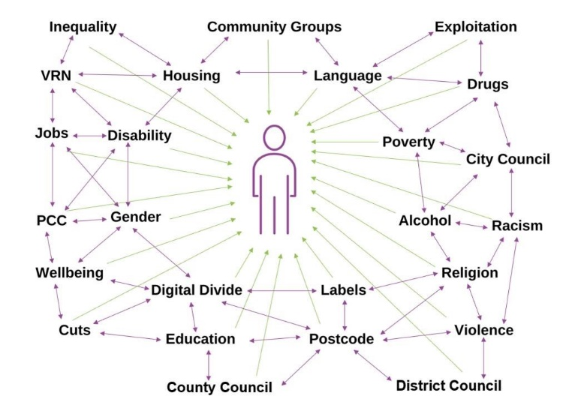
In many cases these issues are complex, interrelated and “solutions” will need to embrace this complexity and look for a system based approach that acknowledges and responds to this.
How will we decide what issues to work on.
Our group works on a consensus model based on transparent discussion at our regular meetings. We are also aware that our resources are limited and it likely that in any one year we can only work on two or three of these issues.
How will we resource the group.
Leicestershire Cares has provided initial resources for the group to function. We envisage winning more funding as required through:
- Applications, by Leicestershire Cares on behalf of the group, to relevant donors and foundations.
- Sponsorship from the business sector, for publications and events.
- Funding from Public Sector.
- We will also seek training from relevant groups who can skill group members up in for example campaigning work.
How will we deal with disagreement or conflict within the group.
Our approach since May 2022, has to be open and transparent in our decision making and to work without “silo, ego or logo”. This has led to a positive and constructive group culture.
We will continue to seek to work in this manner, where the emphasis is on reaching consensus and acknowledging openly when we cannot. Our experience is there are enough areas of common interest where we can work together.
How will we avoid becoming a clique.
We are aware that for many reasons many community groups with relevant experience and practice might not wish to join our network. We will, however, seek to proactively include them when developing “Policy Asks” , where they have expertise and invite them to relevant forums and events.
Ongoing reflection and learning.
As with all groups and organisations we are aware that circumstances, context, organisations and people change, and what worked yesterday might not work tomorrow. So, we are committed to and open to ongoing reflection and learning and adapting how we are structured and operate as needs arise.
Since we started meeting in May 2023, we have already started to have an impact and are confident in the years ahead we can have more. This agreement, although light in touch, does we believe capture, the spirit, soul and intent of our work.
#PowerToChange Partners Group
July 2023
Examples of meetings
https://www.leicestershirecares.co.uk/about-charity/news-events-/powertochange-community-partners-keen-work-systemic-partnership-city-council/
https://www.leicestershirecares.co.uk/about-charity/news-events-/city-mayor-keen-work-partnership/
https://www.leicestershirecares.co.uk/about-charity/news-events-/powertochange-partners-keen-develop-and-work-partnership/
https://www.leicestershirecares.co.uk/about-charity/news-events-/powertochange-partners-meet-steve-meadwell-centre-social-justice/
https://www.leicestershirecares.co.uk/about-charity/news-events-/powertochange-partners-network-meet-asst-mayor-mustafa-malik/
https://www.leicestershirecares.co.uk/about-charity/news-events-/power-change-partners-discuss-aftermath-riots-and-meet-asst-mayor-danny-myers/

